# Travel Diary

It is a digital diary for every traveller. This app allows user to add their current location as they enjoy their journey along with name and description. This will be stored in core data of the app and it can be retrieved every time user opens the app.

The app has multiple view controller scenes.The scenes are described in detail below:

**LOGIN SCREEN:**

Travel Diary uses **Google Sign**-**In**. It is a secure authentication system that reduces the burden of **login** for users, by enabling them to **sign in** with their **Google** Account—the same account they already use with Gmail, Play, and other **Google** services.

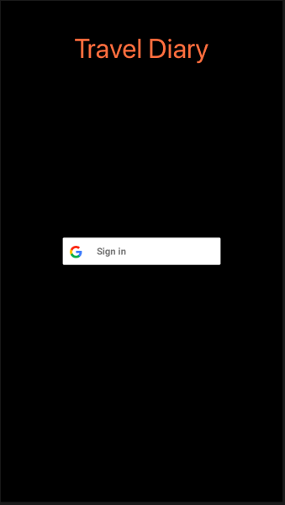

**LOCATIONS VIEW:**

This view will show all the previous saved pins. Tapping on any of the shown pins will take user to the detail view page for that particular pin. The page also shows tabs for Map view and List View. Clicking on them will navigate the user to the desired view. Also, tapping on add button will take user to a page to add new pin for current location. Using logout button can bring the user out of the app.

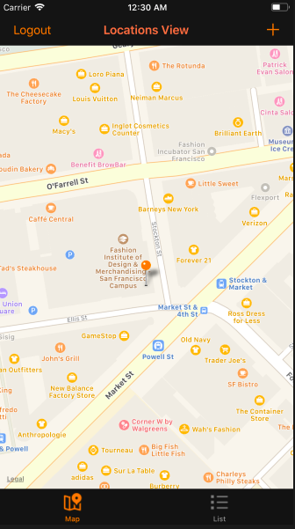

### **LOCATIONS LIST :**

This provides names of all the previously saved locations with recently added location at the top. Tapping on any of the names will take user to the details view page for that particular location.

User can add new location, can logout from this page.

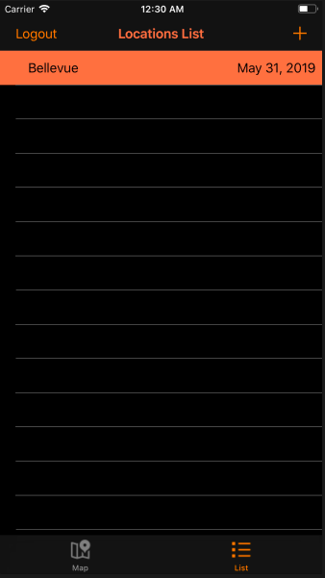

### **ADD LOCATION:**

This provide user to save current location with name and description. User can save only one location on one latitude and longitude.

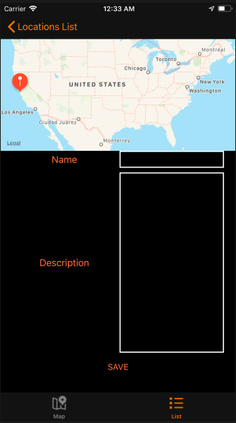

### **Show Detail:**

The page shows detail about the saved location. Pressing the Edit button can take user to an editable page for the corresponding location.

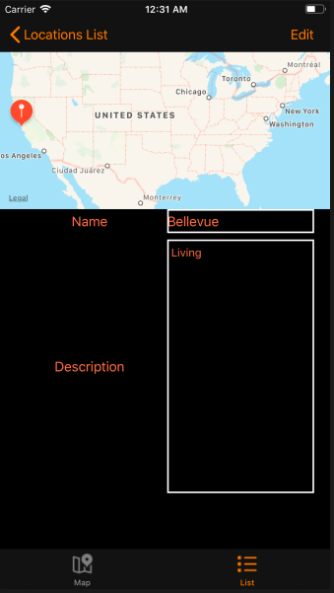

### **EDIT LOCATION:**

This page allows user to edit or delete name or description of previous saved location.

